Trick or Treat On Havana Street at The Gardens on Havana Map • SAT, October 26, 2019 12-4pm or while candy supplies last • See List of Participating Stores Below
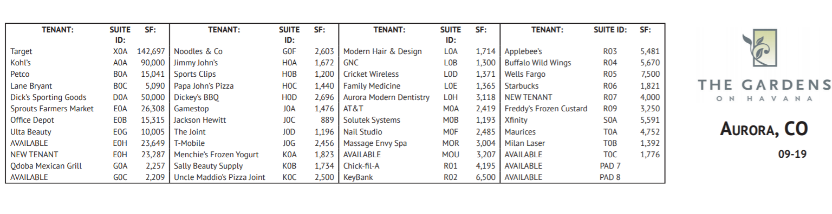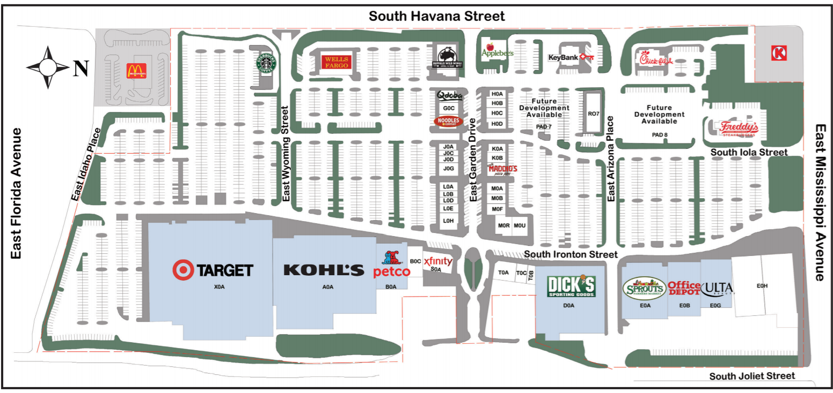

*Applebee's Neighborhood Grill + Bar
Appifix
AT&T - Connect Wireless
Aurora Modern Dentistry
Buffalo Wild Wings
Chick Fil A
Cricket Wireless
Dickey's BBQ
Dick's Sporting Goods
Family Medicine of the Rockies
Freddy's Frozen Custard & Steakburgers
Game Stop
Jimmy John's
Kohl's
Massage Envy
Maurice's
Menchie's
Milan Laser Hair Removal
Modern Hair
Nail Studio
Noodle's & Company
Office Depot
Papa John's
Petco
Sally Beauty Supply
Sports Clips
Sprouts
Starbucks
Spirit Halloween (former Toys R Us)
Target
The Joint
T-Mobile
Ulta Beauty
Uncle Maddios Pizza
*****Comcast/Xfinity, GNC, Key Bank, Lane Bryant, McDonald's, Qdoba and Wells Fargo are not able to participate due to corporate rules & policies.

