On Havana Analytics: May 14th

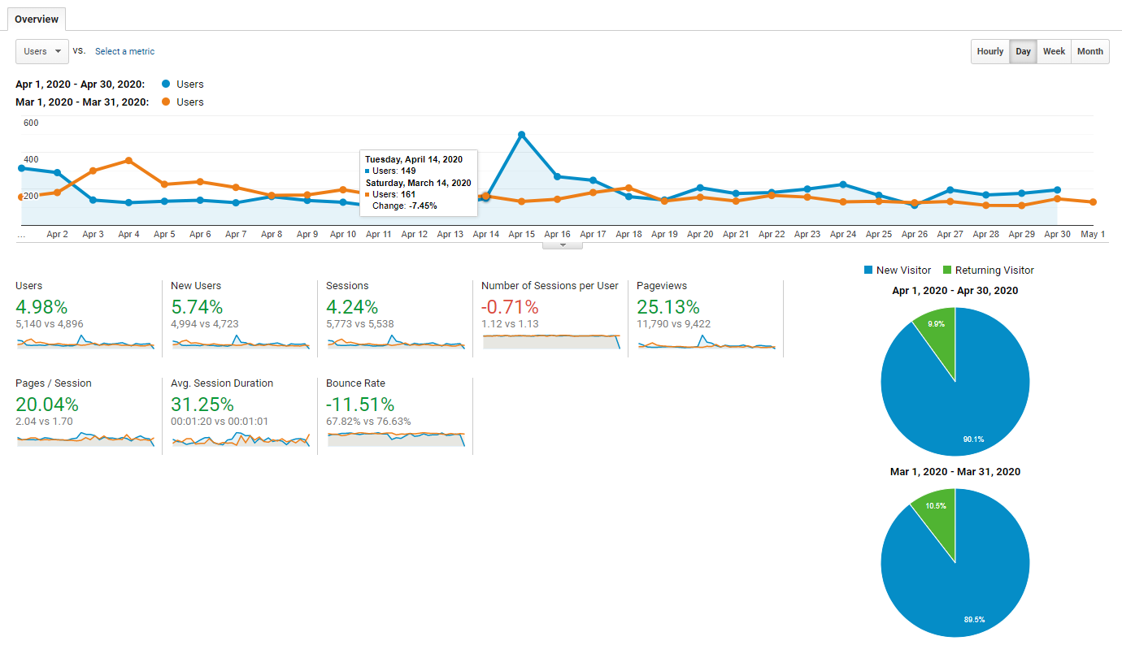
April Analytics
- Traffic in April up 4.24% (vs March)
- Organic traffic in April up 0.25% (vs March)
- Organic traffic = 70.24% of traffic
- Notable:
  - Direct traffic up 22.86% over March (23.89% of traffic). Was 20% in March.
  - Referral traffic up 26.88% but only 2.28% of traffic
  - Social traffic down 9.36% but only 3.56% of traffic
  - 2 Visitors from Email (perhaps just not using UTM codes or getting counted as direct or referral)
Top Pages:
- Home
- COVID Business Closures (up 214%)
- Aurora Restaurants (up 394%)
- Eat On Havana 2020 (up 231%)
- Business Directory (up 91%)

Over previous year
- Traffic up 0.45%
- Organic search traffic up 40.42% over previous year
ENews – Sent May 2
- Deliverable List Size: 4,327
- May eNews
  - 16% open rate (Down from 23% in April)
  - 40.55% click rate (up from 33.2% in April) with a CTR of 6.4% click through rate (down from 7.7% in April)
  - 6 unsubscribes
  - 0 Spam reports
- Top clicks:
  - Eat on Havana (69)
  - Homepage (65)
  - COVID Business Closures and Adjusted Hours (55)
  - Take Out Delivery (42)

COVID Resources Question = 1 Entry

Restaurant Week Entries = 300 to date

Small Business Giveaway = 152 to date

