Trick or Treat On Havana Street at The Gardens on Havana Map • October 26, 2019 12-4pm or while candy supplies last • See List of Participating Stores Below
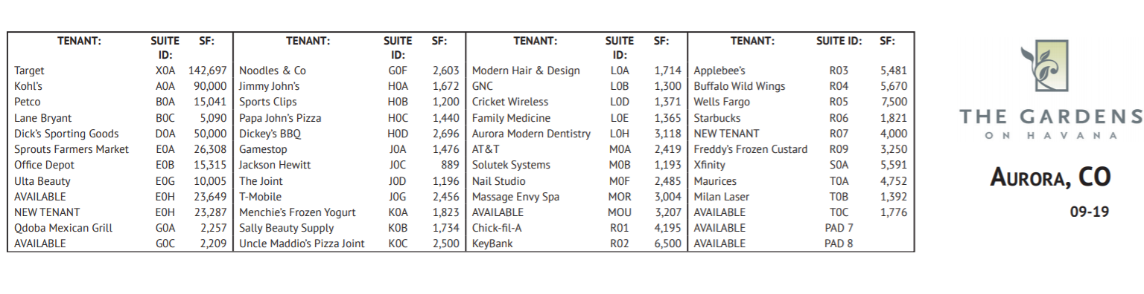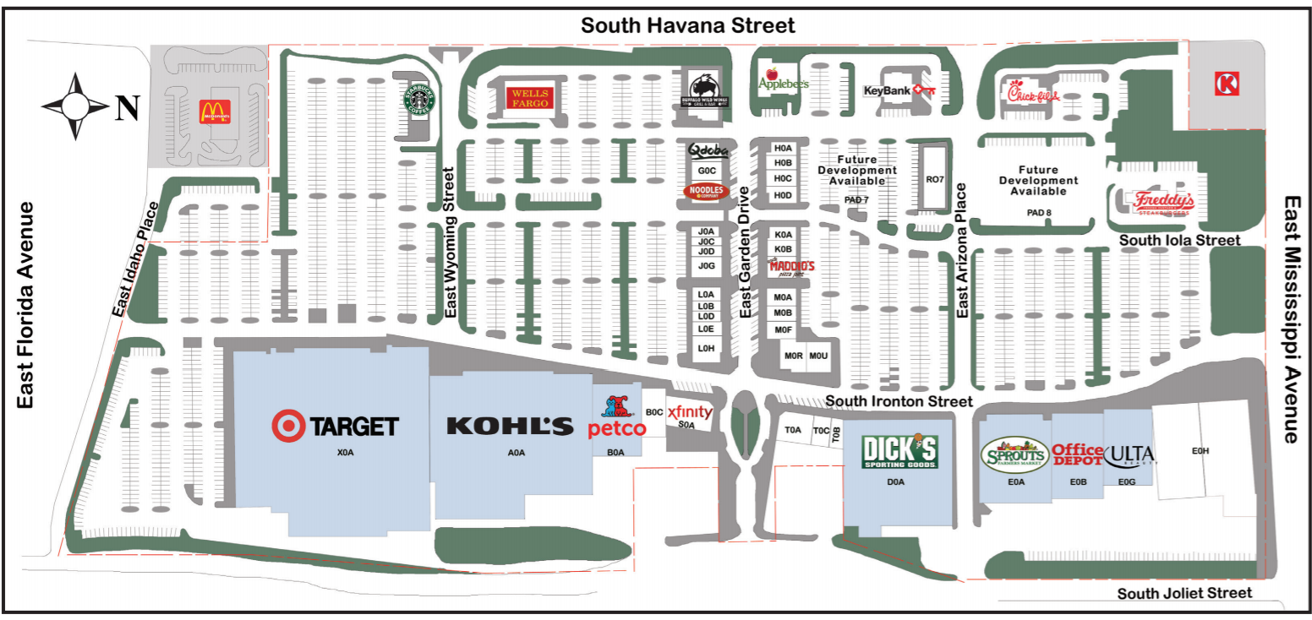

Applebee's Neighborhood Grill + Bar
Appifix
AT&T
Aurora Modern Dentistry
Buffalo Wild Wings
Chick Fil A
Cricket Wireless
Dickey's BBQ
Dick's Sporting Goods
Family Medicine of the Rockies
Freddy's Frozen Custard & Steakburgers
Game Stop
Jimmy John's
Kohl's
Massage Envy
Maurice's
Menchie's
Modern Hair
Nail Studio
Noodle's & Company
Office Depot
Papa John's
Petco
NO CANDY – Lane Bryant, Wells Fargo, Xfinity/Comcast, Qdoba, Key Bank & McDonalds
Sally Beauty Supply
Sports Clips
Sprouts
Starbucks
Target
The Joint
T-Mobile
Ulta Beauty
Uncle Maddios

