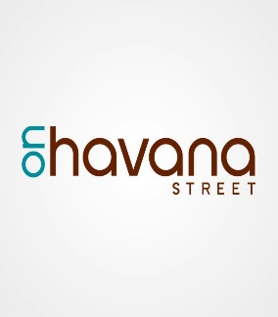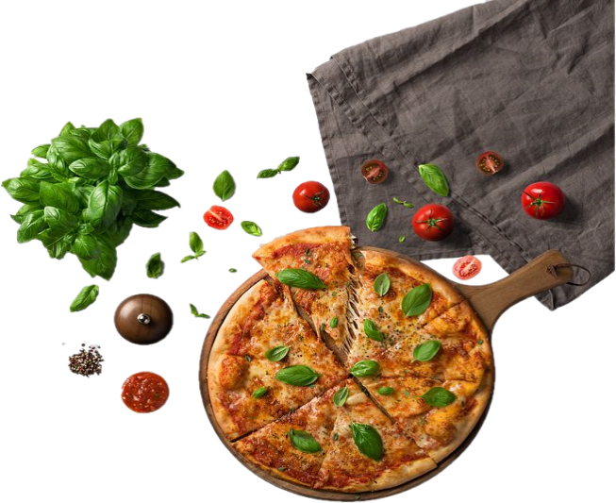k

**Times: 2pm -5pm**

**When: July 15, 2020**

**Where: Stampede Parking Lot**

**2430 S. Havana St.**

**Aurora, Co 80014**

Rocky

Mountain

Welcome

Center

O BOK

**Korean Rice Cake**

**Ifka Cafe**

**3 ways you can help at**

**FoodKitchenCollective.com**

**Join us on July 15th for:**

**#1000Tables**

**A Supporting Small Business Food Drive**

**In Partnership with local small business FKC will be handing out 1000 bags of groceries to families and**

**Solomon Bakery**

**Ifka Cafe**

**Ifka Cafe**

**Ifka Cafe**

**Ifka Cafe**

**Ifka Cafe**

**That food is donated directly to families, individuals, and organizations in need**

Karlyn Shorb

Chief Executive Officer, Aurora Sister Cities International

(720)309-9415

kshorb@auroragov.org

Chance Horiuchi

Executive Director, Havana Business Improvement District

(720)788-8986

Chance@onhavanastreet.com

**Who We Are**

**FKC is Co-0p of local organizations, working together**

**Become a Volunteer**

**Give a Cash Donation**

**Donate non-perishable food**

**When you donate, your donation is used to purchase high quality food from local small businesses**

**CONTACT US**

**Who We Are**